CGF3M- Forces of Nature

Flooding
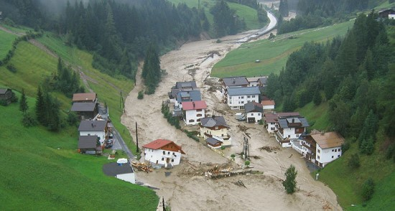
A flood occurs when water overflows or inundates land that is normally dry. This can happen in many ways including heavy rain, snowmelt, storm surges and tsunamis. In any case, flooding occurs when the delivery of water exceeds the rate of infiltration of water into the ground. Flooding is most likely to occur in low-lying areas near coastlines, rivers and lakes.
What are 4 natural and/or human events that can cause flooding?
❏ Deforestation
❏ Heavy and prolonged rainfall
❏ Construction of buildings
❏ The melting of snow and ice

The Hydrological Cycle
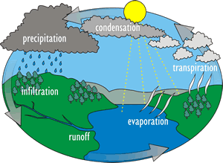
The hydrological cycle has an underlying influence in the occurrence of flooding. The hydrological cycle occurs when water produced by plants during transpiration and water from oceans evaporates and undergoes condensation to produce rainfall. When rain falls, it runs over the land and it is absorbed through a process known as infiltration. The process keeps repeating itself thereafter. In areas where there is frequent and prolonged rainfall, flooding occurs mainly due to inability of land to absorb any more water thus resulting to an overflow.
In your own words explain the water cycle
and its relation to flooding.

Explain how infiltration, percolation, and runoff created flood conditions.
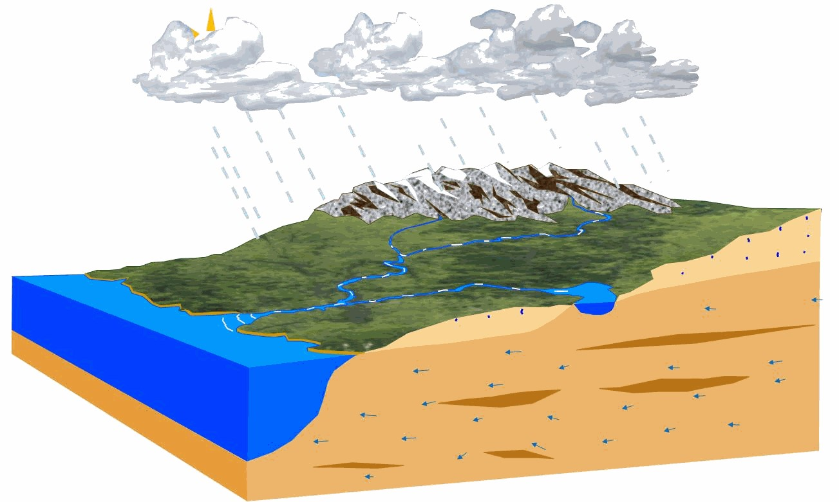
CGF3M- Forces of Nature
When there is rainfall the soil wets up and some of the water enters into the soil. If heavy rainfall keeps occurring the soil’s percolation capacity continues to decrease and the excess water flows into nearby streams. If the rains happen to prolong for a long time a run off occurs which eventually results to flooding.
Dams  When dams happen to burst due to excess water that they can’t contain it results to flooding in the surrounding areas. | Levees  If a river happens to have levees on one side, water is pushed across the other side of the river causing flooding in the surrounding areas. | Spillways  When there is heavy and prolonged rainfall water tends to flow over the spill way or break it thus resulting to flooding in the nearby surroundings.
In Cities
Poorly constructed urban drainage systems result to flooding during periods of heavy and prolonged rainfall. The water accumulates on one area because it can not flow due to drainage blockage.
How do each of the following conditions make the Huntsville area so susceptible/prone to flooding?
Condition | Details | Your explanation of how each impacts flooding (2-3 sentences)
Climate | High snowfall, moderate precipitation, seasons | When snow melts at a fast rate, it becomes water which eventually collects up in surrounding areas due to poor soil drainage causing flooding.  Continuous moderate precipitation results to the soils in an area being unable to percolate or infiltrate any more water resulting to flooding.
Geology | The Canadian Shield is hard, solid rock. | The hard-solid rock is impermeable thus making sure that water does not infiltrate or percolate during heavy rainfall. This causes a run off which results to flooding in the surrounding areas.
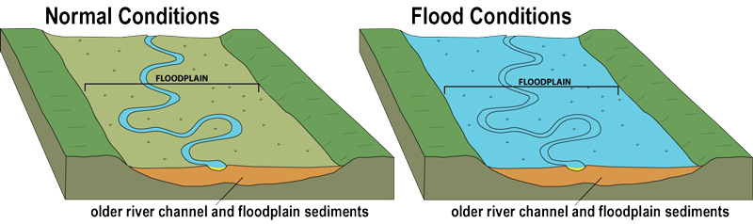
A flood plain is a low -lying area that is adjacent to a river or stream.
What is a floodplain?
****You should choose to complete these last two questions after you complete the two case studies****
Identify 2 connections between floodplains, deltas and flooding events.
The sediments from the river or stream usually form two land areas. The flood plains and the deltas. When there is heavy and prolonged rainfall, the water from the river or stream overflows and collects in the nearby flood plains and deltas thus resulting to flooding.

What are 3 strategies/structures or decisions humans can make to prevent or minimize the impacts of flooding?
- Planting more trees to replace the ones they cut
- Constructing buildings above flood levels
- Putting up more stable flood barriers
Screenshot or paste and image of each and provide a one sentence explanation of how it protects humans from flooding.

Figure 1: Tree planting reduces the chances of flooding because trees soak up excess water thus preventing run off which lead to flooding.
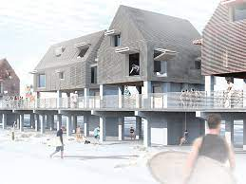
Figure 2: During construction, the builders should ensure that the houses are above the flooding levels to avoid death and damage of property during floods.
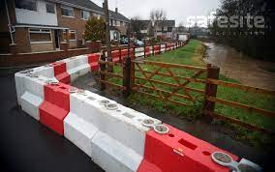
Figure 3: Both temporary and permanent flood barriers should be constructed to prevent flooding of surrounding areas.
CGF3M- Forces of Nature

